**FCFS Scheduling**

**Program**

#include<stdio.h>

void main()

{

int lim,bt[20],i,wt[20],tat[20],tw=0,tt=0;

float avw,avt;

int p[20];

printf("enter number of processes:\n");

scanf("%d",&lim);

printf("enter process numbers:\n");

for(i=0;i<lim;i++)

{

scanf("%d",&p[i]);

}

printf("enter burst time of each processes:\n");

for(i=0;i<lim;i++)

{

scanf("%d",&bt[i]);

}

wt[0]=0;

tat[0]=bt[0];

for(i=1;i<lim;i++)

{

wt[i]=wt[i-1]+bt[i-1];

tat[i]=wt[i]+bt[i];

}

for(i=0;i<lim;i++)

{

tw=tw+wt[i];

tt=tt+tat[i];

}

avw=tw/(float)lim;

avt=tt/(float)lim;

printf("process\tburst time\twaiting time\tturn around time\n");

for(i=0;i<lim;i++)

{

printf("%d\t%d\t\t%d\t\t%d\n",p[i],bt[i],wt[i],tat[i]);

}

printf("average waiting time=%fms\n",avw);

printf("average turn around time=%fms",avt);

}

**Output**

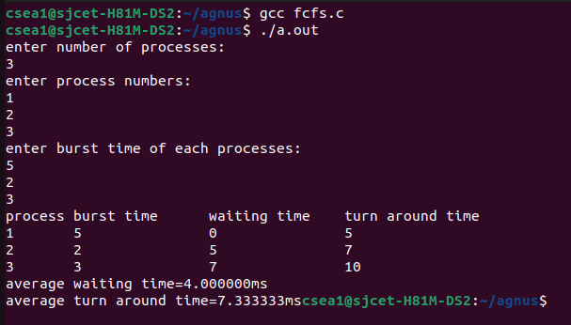

**SJF Scheduling**

**Program**

#include<stdio.h>

void main()

{

int lim,bt[20],i,j,wt[20],tat[20],tw=0,tt=0,temp1,temp2;

float avw,avt;

int p[20];

printf("enter number of processes:\n");

scanf("%d",&lim);

printf("enter process numbers:\n");

for(i=0;i<lim;i++)

{

scanf("%d",&p[i]);

}

printf("enter burst time of each processes:\n");

for(i=0;i<lim;i++)

{

scanf("%d",&bt[i]);

}

for(i=0;i<lim;i++)

{

for(j=i+1;j<lim;j++)

{

if(bt[i]>bt[j])

{

temp1=bt[i];

bt[i]=bt[j];

bt[j]=temp1;

temp2=p[i];

p[i]=p[j];

p[j]=temp2;

}

}

}

printf("sorted processes:\n");

printf("process\tburst time\n");

for(i=0;i<lim;i++)

{

printf("%d\t%d\n",p[i],bt[i]);

}

wt[0]=0;

tat[0]=bt[0];

for(i=1;i<lim;i++)

{

wt[i]=wt[i-1]+bt[i-1];

tat[i]=wt[i]+bt[i];

}

for(i=0;i<lim;i++)

{

tw=tw+wt[i];

tt=tt+tat[i];

}

avw=tw/(float)lim;

avt=tt/(float)lim;

printf("process\tburst time\twaiting time\tturn around time\n");

for(i=0;i<lim;i++)

{

printf("%d\t%d\t\t%d\t\t%d\n",p[i],bt[i],wt[i],tat[i]);

}

printf("average waiting time=%fms\n",avw);

printf("average turn around time=%fms",avt);

}

**Output**

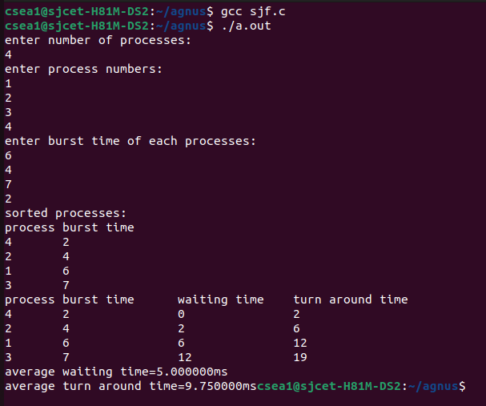

**Priority Scheduling**

**Program**

#include<stdio.h>

void main()

{

int lim,bt[20],i,j,wt[20],tat[20],tw=0,tt=0,temp1,temp2,temp3;

float avw,avt;

int p[20],pr[20];

printf("enter number of processes:\n");

scanf("%d",&lim);

printf("enter process numbers:\n");

for(i=0;i<lim;i++)

{

scanf("%d",&p[i]);

}

printf("enter burst time of each processes:\n");

for(i=0;i<lim;i++)

{

scanf("%d",&bt[i]);

}

printf("enter priority of each processes:\n");

for(i=0;i<lim;i++)

{

scanf("%d",&pr[i]);

}

for(i=0;i<lim;i++)

{

for(j=i+1;j<lim;j++)

{

if(pr[i]>pr[j])

{

temp1=pr[i];

pr[i]=pr[j];

pr[j]=temp1;

temp2=p[i];

p[i]=p[j];

p[j]=temp2;

temp3=bt[i];

bt[i]=bt[j];

bt[j]=temp3;

}

}

}

printf("sorted processes:\n");

printf("process\tburst time\tpriority\n");

for(i=0;i<lim;i++)

{

printf("%d\t%d\t\t%d\n",p[i],bt[i],pr[i]);

}

wt[0]=0;

tat[0]=bt[0];

for(i=1;i<lim;i++)

{

wt[i]=wt[i-1]+bt[i-1];

tat[i]=wt[i]+bt[i];

}

for(i=0;i<lim;i++)

{

tw=tw+wt[i];

tt=tt+tat[i];

}

avw=tw/(float)lim;

avt=tt/(float)lim;

printf("process\tburst time\tpriority\twaiting time\tturn around time\n");

for(i=0;i<lim;i++)

{

printf("%d\t%d\t\t%d\t\t%d\t\t%d\n",p[i],bt[i],pr[i],wt[i],tat[i]);

}

printf("average waiting time=%fms\n",avw);

printf("average turn around time=%fms",avt);

}

**Output**

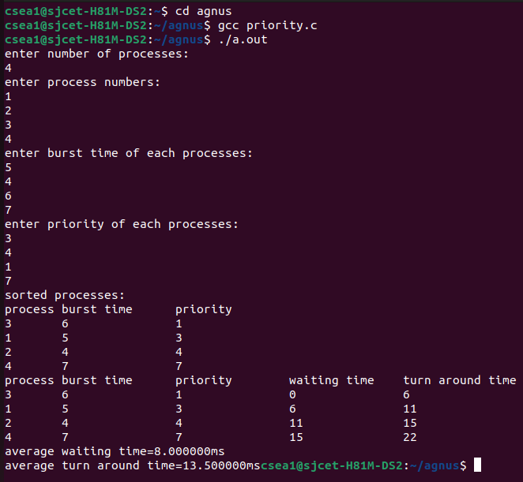

**Round Robin Scheduling**

**Program**

#include<stdio.h>

void main()

{

int tq,bt[20],p[20],num,i,rem[20],wt[20],tat[20],tqi,count=0,twt=0,tt=0;

float att,awt;

printf("enter number of processes:");

scanf("%d",&num);

printf("enter time quantum:");

scanf("%d",&tq);

printf("enter processes:");

for(i=0;i<num;i++)

{

scanf("%d",&p[i]);

}

printf("enter burst time for each processes:");

for(i=0;i<num;i++)

{

scanf("%d",&bt[i]);

rem[i]=bt[i];

}

tqi=0;

while(count<num)

{

for(i=0;i<num;i++)

{

if(rem[i]>tq)

{

tqi=tqi+tq;

rem[i]=rem[i]-tq;

}

else if(rem[i]>0&&rem[i]<=tq)

{

tqi=tqi+rem[i];

rem[i]=0;

wt[i]=tqi-bt[i];

tat[i]=tqi;

count++;

}

}

}

for(i=0;i<num;i++)

{

twt=twt+wt[i];

tt=tt+tat[i];

}

awt=(float)twt/num;

att=(float)tt/num;

printf("process\tburst time\twaiting time\tturn around time\n");

for(i=0;i<num;i++)

{

printf("%d\t%d\t\t%d\t\t%d\n",p[i],bt[i],wt[i],tat[i]);

}

printf("average waiting time=%fms\n",awt);

printf("average turn around time=%fms",att);

}

**Output**

